**RESULTS AND DISCUSSION**

1. Number of lines of code:

The code we have made contains 571 number of lines of BST code and around 350 number of lines of linked list code.

1. Time complexity:

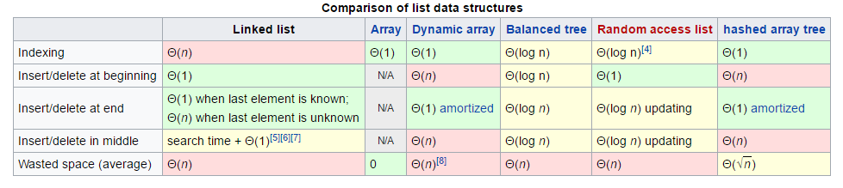

In BST data structure we just keep a tree in ordered or sorted form and stores “items” in memory. It allows insertion and deletion of items at a fast rate and can be used to implement lookup tables that allows finding an item by its key (which we have used here) e.g., finding the phone number of a person by the help of name.

|  |
| --- |
| [**Time complexity**](https://en.wikipedia.org/wiki/Time_complexity)**in**[**big O notation**](https://en.wikipedia.org/wiki/Big_O_notation) |
| |  |  |  |  | | --- | --- | --- | --- | | **Algorithm** |  | **Average** | **Worst Case** | | **Space** |  | O(*n*) | O(*n*) | | **Search** |  | O(log *n*) | O(*n*) | | **Insert** |  | O(log *n*) | O(*n*) | | **Delete** |  | O(log *n*) | O(*n*) | |

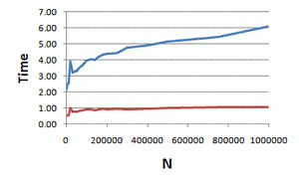 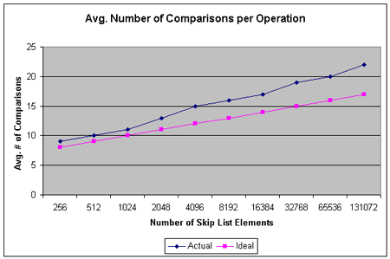

Linked list is another way of data structure which is a linear collection of data. Elements, consists of group of nodes which together represent a sequence. It allows fast insertion and removal from any position in the sequence during iteration.

